**WADL Assignment 2b**

(Docker Desktop)

(Docker Hello-World App)

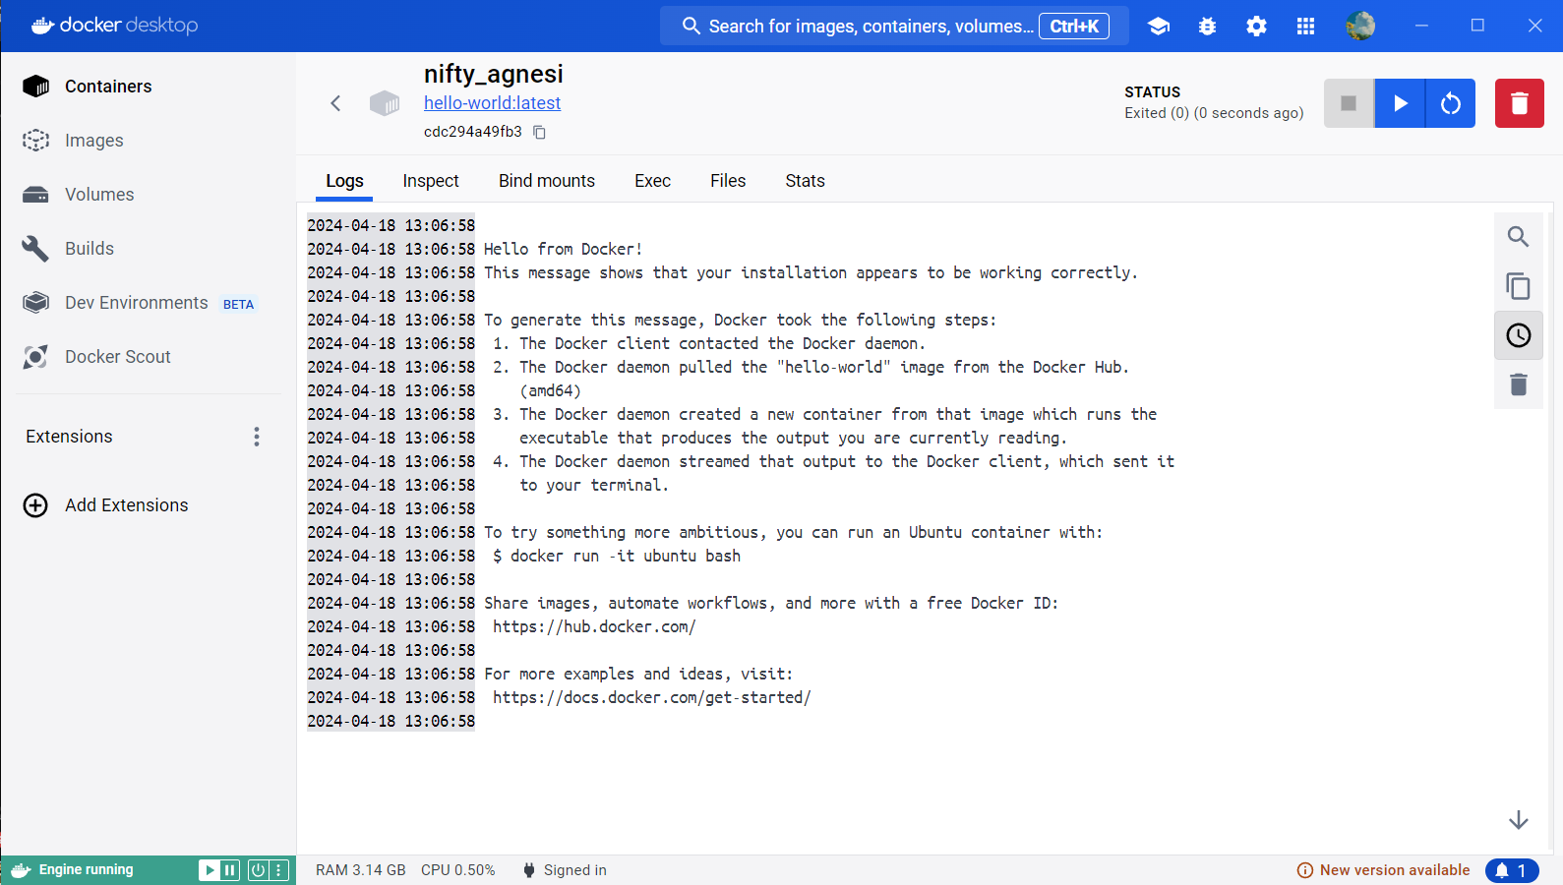

(Docker Hello-World App)

(Ubuntu Image on Docker)